ABFRP Standard Operating Procedures for Baseline Monitoring

On each site the following details need to be monitored:

1. Litter
2. Deadwood
3. Above ground biomass
4. Soil carbon
5. Noors coverage
6. Biodiversity

The first 5 groups are measured in order to determine the amount of carbon, and are therefore termed “carbon pools”. The last Certain calculations cannot be done until measures of the density of deadwood classes have been undertaken. In addition, an allometric equation for noors (*Euphorbia coerulescens*) needs to be derived, in order to allow the estimation of noors coverage in all sites. Nevertheless, the initial measurements can be undertaken, and the calculations finalised once these variable have been derived.

The methodology for measurement of the variables is described in the ABFRP project document, as are the variables to be measured and recorded.

# Selection of monitoring sites

1. Using the required equations from the chosen methodology (page 46 of AR-AMS0002[1]), calculate the number of required monitoring plots per stratum. Stratification criteria include:
   1. Cohort (all plantings within a 5 year period are defined as a single cohort).
   2. Burn areas (areas that have undergone a burn will be assigned to a separate “burn stratum and monitored independently).
2. Initial calculations give a number of 10 sites for each stratum, and this is expanded to 15 to ensure redundancy in case of site damage or removal.
3. Within each sub-stratum (5 year planting plan), divide the number of monitoring plots by five to obtain the number of sites to be assigned to each planting year. Randomly assign any remainder amongst the planting years.
4. Using a GIS programme, determine random locations within the area designated for each planting year. This can be done using ArcView and the “Generate Random Points” tool from the freely available Hawth’s Tools scripts[2] or some other appropriate site-selection GIS algorithm. If an alternate method is used, this must be reported and documented. Assign the number of plots per area determined in step 2.
5. Assign each monitoring plot a permanent ID, using the following structure:
   1. the first letter of the protected area (A = Addo, B = Baviaanskloof, G = Great Fish River);
   2. a two-digit number for the project instance within the protected area (01 for the first, 02 for the second, etc), followed by a period (.);
   3. a three-digit number for the number of the monitoring plot within the project instance.
6. An example of a plot ID is: **A1.21**, which means Darlington Dam area, of the Addo Elephant National Park, site 21.
7. Record the ID in the project database.
8. Once monitoring has been undertaken, review the means and standard error for each carbon pool within the stratum. If the standard error is greater than 10% of the mean at a 95% confidence level, additional monitoring sites must be assigned to each stratum. The number of sites can be calculated using the equations on page 46 of the methodology.
9. Current baseline monitoring sites are appended at the end of this document.

# Field component

The recommended order of procedures for a given sites is as below. It is possible to deviate from this proposed order, especially if (for example) biodiversity is to be measured across all permanent monitoring sites, followed by the remaining criteria.

1. Plot demarcation.
2. Fixed point photography.
3. Transect monitoring (biodiversity belt transect and lying deadwood).
4. Biodiversity monitoring (quadrats).
5. Aboveground biomass assessment (spekboom and noors).
6. Litter monitoring.
7. Soil sampling.

Following this schedule minimizes the impacts of each procedure on the following procedure. Details of the processes are given below.

## Data tracking

A field inventory should be completed in order to ensure that no samples are lost between the field and the lab. Every time a sample is collected, register it in the field inventory. Store field inventories with the data record sheets for the field site to allow for easy checking that all samples are present when the warehouse work is undertaken.

## Plot demarcation

1. For each plot, 9 separate permanent markers will be placed. These comprise the four corner points and the centre point of the 10 m x 10 m plot (see Figure 1a), and the ends of the 50 m transects through the plot.
2. Firstly, use the GPS coordinate specified to demarcate the southwest corner of the sampling plot. Drive an iron stake into the ground as a permanent marker. Iron stakes should be topped with a metal disc, and should be driven all the way into the ground to ensure that animals cannot injure themselves on the stakes.
3. Walk 10 m north, and place a second marker. Each of the additional corner points can be placed by triangulation using either two tape measures or ropes of appropriate lengths (see Figure 2). This will ensure that the plot is exactly 10 m x 10 m.
4. The central point can be accurately placed by measuring the midpoint of the diagonal across the permanent plot (7.071 m from either corner; see Figure 2).
5. Alternatively, the four corner points can be accurately placed using a highly accurate (sub-50 cm) GPS device.
6. Should any of the corner points be impossible to place because they coincide with the location of a tree or large bush, the entire plot should be moved up to a metre in order to accommodate the points. Try to minimise the distance by with the plot is displaced.
7. Accurately record the locations of each of the corner points in the Site Record data sheet. Exact locations should be determined using a GPS device. Ensure that the locations are as accurate as possible.
8. The four end points for the 50 m transect lines can be found by extending a perpendicular line from the central point through the centre (5 m) of each of the plot boundary lines.
9. The distance should be measured using a steel tape measure, and care should be taken to ensure that the line is as straight and level as possible. Use a steel pole to push the measure line through bushes and under trees that are inaccessible.
10. Once placed, all permanent markers should also be surrounded/covered with rocks, to assist in visibility and ensure that they are protected.

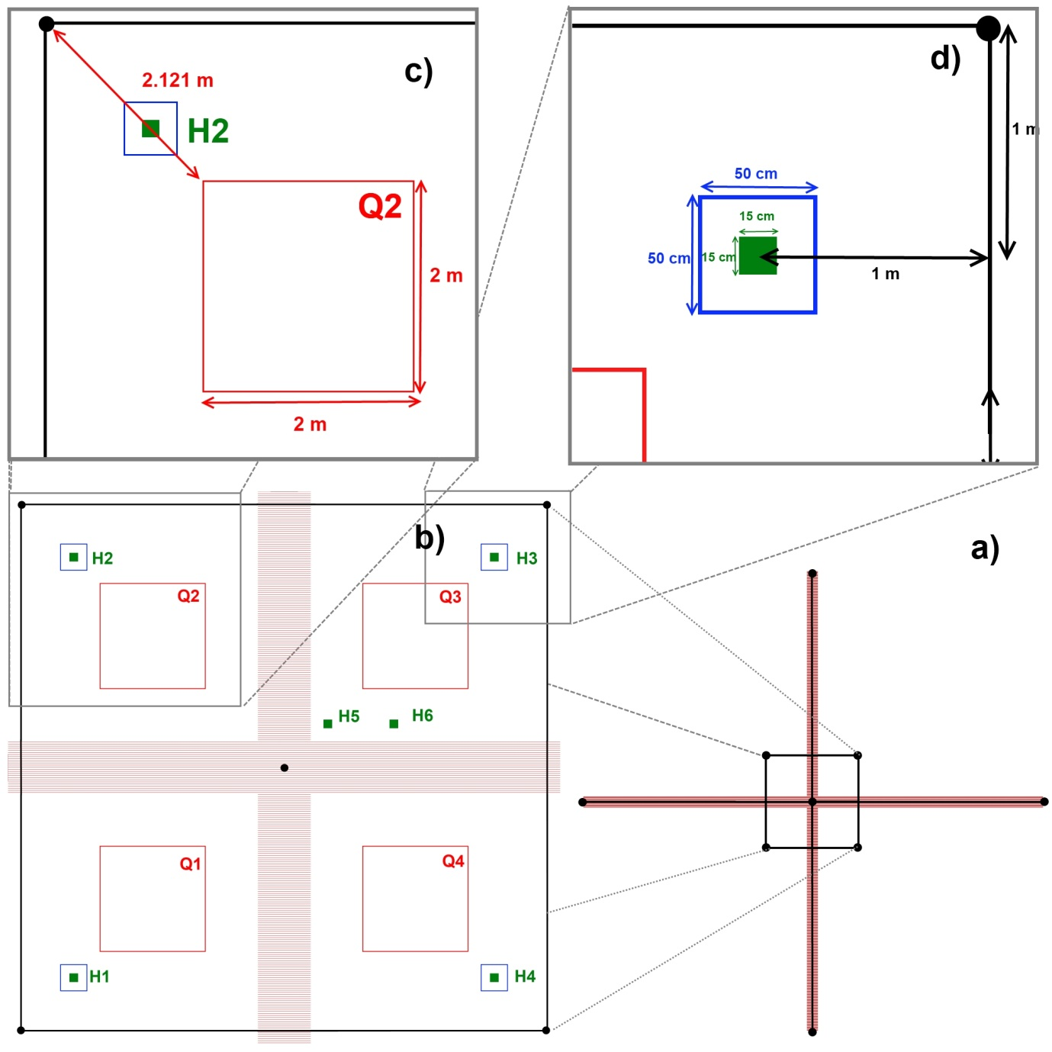

Figure : Details of the layout of a sample plot, detailed clockwise from lower right. a) Full plot layout, showing the permanent markers (black dots) and the belt transects; b) permanent plot with the biodiversity quadrats (red), the litter sampling sites (blue) and the soil sampling locations (green); c) details on locating the biodiversity assessment quadrats within the plot; and d) details for locating the litter and soil sampling sites within the plot.

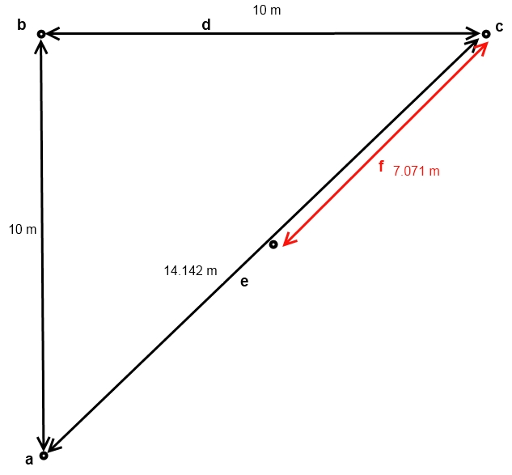

Figure : Triangulation of the corner points. Given two points 10 m apart (points a and b) the third corner point (c) can easily be found by finding the intersection of two ropes of the specified lengths (d: 10 m; and e: 14.14 m). The centre point for the plot is found by measuring halfway along the diagonal (7.071 m).

## Fixed point photography

1. Fixed point photography should ideally be taken when the sun is high in the sky (i.e., not early morning or late afternoon) to ensure that the sun is not at an acute angle.
2. Set up a tripod at the southwestern corner of the plot, ensuring that as much of the plot as possible is captured within the field of view of the camera. The tripod should be at least 1 m high.
3. If there is not a good view of the plot from the southwestern point, move the camera up to 5 m away in order to capture a good proportion of the plot.
4. Take a photograph of the entire permanent plot. A digital copy of this image should be provided to the
5. With a GPS, record the location of the tripod to nine decimal places in the Site Record datasheet.

## Deadwood sampling

Deadwood comprises two components: i) trees that are dead, but remain standing, and ii) fallen trees and branches on the ground. Both of these need to be measured for dead *P. afra* ONLY.

1. Measure the basal diameter of all dead standing *P. afra* plants in the entire sampling plot.
2. For each dead tree or stump, record which of the following decomposition classes it falls under:
   1. tree with branches and twigs that resembles a live tree (except for leaves);
   2. tree with no twigs but with persistent small and large branches;
   3. tree with large branches only; and
   4. bole only, no branches.
3. Lying deadwood is measured along the 50 m long transects established through the permanent plot.
4. Extend a steel tape measure from one transect end point to the other, bisecting the plot.
5. Using digital callipers, measure the diameter in millimetres of all lying dead wood (≥5 cm) that touches the line transect, and assign each piece to one of the following density states:
   1. sound;
   2. intermediate; or
   3. rotten.

Variables to be recorded: Basal diameter and decomposition class of all standing dead *P. afra* plants; diameter and density state of all lying dead *P. afra*  that intersects the transects.

## Biodiversity sampling

The biodiversity sampling looks at two different components, for which there are different measurement methods. It is recommended that biodiversity assessment be undertaken at two different times in the year (after the rains, and during the dry season) in order to capture the true variety of annual species in the site.

### Belt transect

1. This procedure is used to measure woody species, and species on the exceptions list that will be developed by the field botanist. Exceptions include noors and substantial aloes such as *Aloe ferox.*
2. Shrubs and trees are measured along the 50 m transects that have been established for measuring deadwood (Figure 1a).
3. Voucher specimens of all species should be collected, in order to provide a field herbarium for long term monitoring. If you encounter a species that has not been previously collected, take a sample of the plant (see “Plant sample preparation” below).
4. The cover of each plant encountered in the 1m band straddling the transect (i.e. 50 cm on each side of the transect) must be measured.
5. For bare ground and each intersecting tree or shrub, record:
   1. the species;
   2. the length of the transect covered by the canopy of the plant (start point, end point and length); and
   3. the maximum width of the plant, up to the edge of the transect.
6. Where two plants of the same species overlap, count their combined cover. If different species overlap, count the entire cover for each plant.
7. Record bare ground as if it were a species: this will allow a calculation of the change in total cover of species as well as relative cover.
8. Ignore the area of plants that falls outside the 1 m transect.
9. Further details on the assessment of canopy and non-canopy cover are provided in Annex 2.

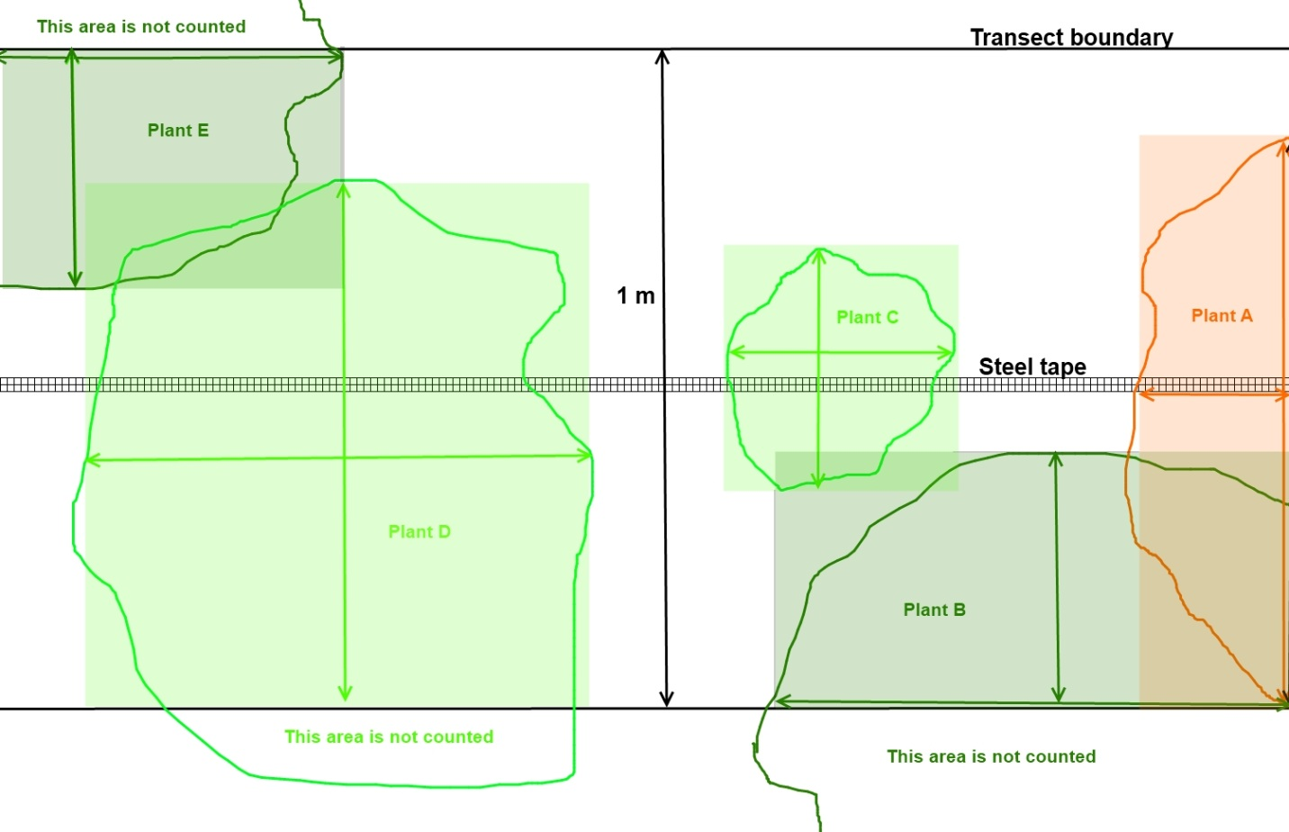

Figure : Diagram of a belt transect, showing the simplified areas of the canopy for each plant. The calculations of the canopy cover are shown in Annex 2: Belt transect monitoring.

### Quadrats

1. Grasses and forbs are measured using quadrats placed in the centre of each quarter of the monitoring plot.
2. Each quadrat should measure 2 m x 2 m. Quadrat frames can be constructed out of many materials, but it is recommended that PVC piping is used because the easiness of field assembly will allow the frame to be placed more easily where there are many plants in the way.
3. The simplest method of placing the quadrats is to extend a line from the corner to the centre point of the plot, and ensure that opposite corners of the quadrat lie on this line. These quadrat corners should each be 2.12 m from the corner and the centre of the plot (see Figure 1c).
4. All plant species within the each quadrat must be measured and recorded.
5. For each species, estimate of the cover of the species within the plot. Again, if you have not previously encountered the species, take a sample and assign the plant a temporary name.
6. Species cover can be estimated by eye, or by using negative space area markers. Try to be as accurate as possible with the estimates.
7. Record the coverage of bare ground. NB: It is possible for the total cover to be larger than 100% if some species overlap others.
8. Keep a record of which quadrat species fall into – this may be important later when examining the variation in alpha diversity.

### Plant sample preparation

1. Take a sample of the plant (a small branch with leaves, and a flower if available).
2. Label the sample (see “Labels”).
3. Stick the sample on to a piece of paper and label it with the temporary name that you have assigned it.
4. Place the sample between two pieces of paper, and place these between cardboard.
5. If you have a plant press, place the sample and cardboard into the plant press. Otherwise, store the samples under a plank on the ground, with a rock or some other weight on top to assist with the pressing process.
6. If possible, take a photo of the plant, ensuring that any distinguishing characteristics are clearly visible.

Variables to be recorded: Canopy cover of each species and bare ground along the belt transects and within each quadrat. Samples to be taken of each new species encountered.

## Litter sampling

1. Locate a point 1 m from either edge of the plot, near the southwest corner (Figure 1c).
2. Place a 50 cm x 50 cm frame around this spot.
3. Collect all the litter (leaves, fruits, small wood ≤5 cm in diameter) falling inside the frame, and place it into a plastic bag. Do not remove growing vegetation.
4. Where the frame cuts across litter, include it in the litter measurement. This avoids the difficulty of attempting to measure fractions of litter components.
5. Repeat for each of the four corners of the permanent plot, combining the litter into a single sample.
6. Label the plastic bag appropriately (see “”), and include a second label inside the bag. Seal the bag and retain it for weighing at the warehouse.

## *Portulacaria afra* sampling

1. The initial sample includes all *P. afra* plants within the 10 m x 10 m permanent monitoring plot.
2. Move from one side of the plot to the other, systematically measuring each plant in the plot.
3. Measure the diameter of each stem with digital callipers at ground level. If it is not possible to measure the diameter at ground level, measure as close as possible to the ground.
4. For stems with a non-circular profile, measure the **widest** diameter at the base of the stem.
5. Record the diameter of the stem on the datasheet and assign it a plant number (all stems from the same plant should have the same number).
6. Once a stem has been measured, mark it with a non-damaging marker (piece of thread, spot of paint, felt-tip marker, etc) to prevent the double-counting of stems.
7. Where the plant has a large fringe of stems growing from the ground, measure all the stems in the fringe, and then progress inwards. It is allowable to remove smaller stems in order to measure the larger stems, but try to avoid damaging the plant as much as possible.
8. Where two plants have fringes that are growing together, extend a rope between them at a point that you estimate is closest to the intersection of the two fringes. Assign all stems on the left to one plant, and all stems to the right to the other plant.

Variables to be recorded: diameter of all *P. afra* stems at ground level, plant number for each stem.

## *Euphorbia coerulescens* sampling

1. The initial sample includes all *E. coerulescens* plants within the 10 m x 10 m permanent monitoring plot.
2. Move from one side of the plot to the other, systematically measuring each *E. coerulescens* stem in the plot.
3. Measure the height of each stem. This can be done with a metre-ruler or a pole with regular height markings inserted into the stand next to each stem.
4. Once a stem has been measured, mark it with a non-damaging marker (piece of thread, spot of paint, felt-tip marker, etc.) to prevent the double-counting of stems.
5. An alternative method of tracking counted stems is to use a rope to demarcate the stems that have already been measured, and move it to include each stem as it is counted.
6. NB: the white latex of these plants is caustic, and can irritate the skin and damage your eyes. You should avoid contact with it as much as possible, and be sure to wash your hands before eating or touching your face. It is recommended that you use heavy gloves when handling the plant.

Variables to be recorded: height of all *E. coerulescens* stems at ground level.

## Soil sampling

The soil sampling procedure is illustrated in Figure 4 below. Additional details are providing in the succeeding paragraphs.

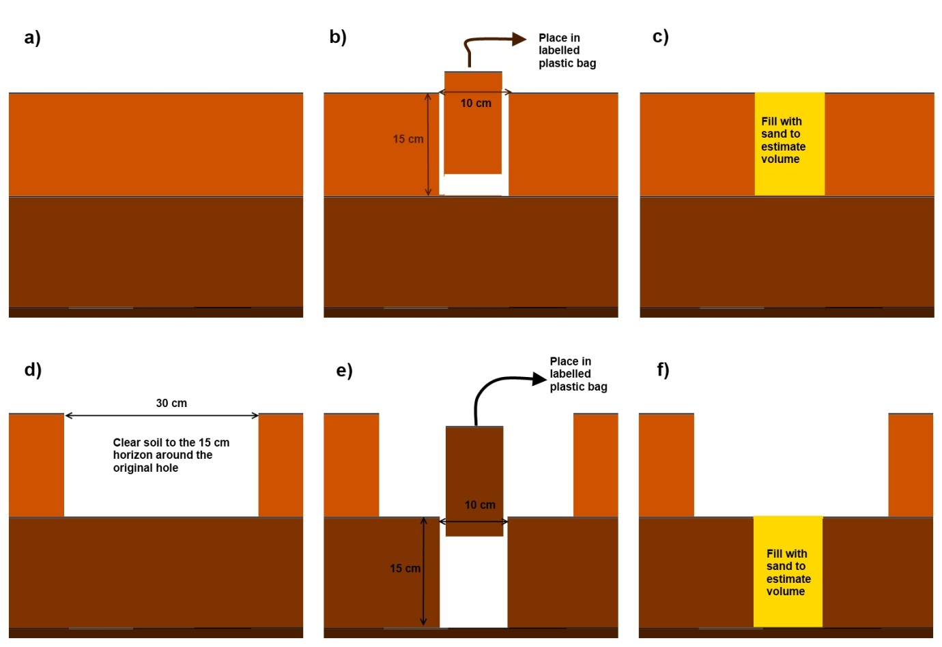

Figure : Soil sampling procedure: a) clear the vegetation and litter from the sampling plot; b) remove the soil from a 10 cm x 10 cm square to a depth of 15 cm and place in a plastic bag; c) fill the hole with sand to estimate the volume; d) clear the soil in a 30 cm x 30 cm area to a depth of 15 cm; e) remove a second profile from 15 cm to 30 cm in depth in a 10 cm x 10 cm area within the cleared area; and f) fill this hole with sand in order to estimate the volume.

### Carbon analysis

1. Five sample plots are to be used; four located within 2 m of each of the corners within the 10 m x 10 m permanent monitoring site, and one at the centre of the site (Figure 1b).
2. The corner soil sampling points should be situated in the centre of the areas already cleared for litter sampling.
3. The centre soil carbon sampling site should be located just outside the belt transect to the northeast (see Figure 1b).
4. If any of these soil sampling sites are likely to intersect with the roots of a large established tree, try to move the site slightly to prevent this intersection.
5. Clear all the litter within a 50 cm radius of the centre of the soil sampling plot. Remove all the vegetation in this area by carefully clipping the plants at the soil surface with secateurs or scissors.
6. In the middle of the cleared area, measure out an area 10 cm x 10 cm.
7. Carefully remove all the soil from this area (and ONLY this area) to a depth of 15 cm, using a small spade or long-handled spoon. Ensure that the walls of the hole are as straight as possible – it may be useful to use a chisel to ensure this. It is extremely important that you make all surfaces as straight and flat as possible.
8. Place all the removed soil into a plastic bag.
9. Re-measure the length of each of the upper edges of the hole, and record this in the Site Record data sheet.
10. Measure the diagonal distances across the hole, and record this in the Sand & Litter Record Sheet.
11. Take a sand bag containing a *known volume* of sand (see “Preparing sand for volumetric analysis”) and prepare a label for it with the plot number (see “Labels”).
12. Carefully pour the sand into the hole, ensuring that none is spilled. Fill the hole to exactly the level of the ground surface, and try not to compress it.
13. Seal the sand bag, so that no sand spills, and label it.
14. Widen the hole to approximately 30 cm x 30 cm, clearing all the way down to the 15 cm horizon. This soil does not need to be retained – the purpose of clearing is to allow a second profile to be taken with relative ease.
15. Measure out an area 10 cm x 10 cm at the bottom of the cleared hole (on the 15 cm horizon).
16. Remove the soil from the 15 cm horizon to the 30 cm horizon within this area (dig a further 15 cm down) and store it in the same soil sample bag as the previous horizon. Again, ensure that the edges are as straight as possible, using fine tools.
17. Record the lengths of each edge and the diagonals as before in the Site Record data sheet.
18. Carefully fill the second hole with sand up to the top in order to estimate the volume of the second sample, as detailed in steps 11 and 12. Seal and label the sand bag once you are finished.
19. Place labels both inside and outside the bags (see “Labels”). It is suggested that internal labels be made from a durable material such as ice-lolly sticks or tongue depressors.
20. Seal all the bags (soil samples and sand bags) and retain them for measurement at the warehouse.
21. If you reach rock before the required depth, dig as far as you can. Estimate the volume of the hole using sand as detailed in steps 11 and 12 above.

### Bulk density analysis

1. Bulk density is measured from a separate hole from the carbon analysis cores. This should be located within 1 m of the central hole (see Figure 1b).
2. The procedure for obtaining samples of soil for bulk density analysis is exactly the same as for the carbon analysis samples.

# Warehouse and laboratory component

## Preparing sand for volumetric analysis

Sand bags must be prepared in order to estimate the volume of the field samples.

1. Obtain builder’s sand with as consistent a grain size as possible. Finer-grained sands are preferable, but the sand size need not be too rigorously controlled.
2. Ensure the sand is dry enough to flow freely (i.e., it does not clump or stick together). If it is not, dry it in the sun or in a warm dry place. It does not need to be dried to a constant mass. If the weather is cold and wet, you may need to use an oven to dry the sand, but it should not generally be necessary.
3. Pour the sand into a measuring cylinder, and shake it lightly in order to help it settle.
4. Measure approximately 2 dm3 (litres) of sand and place it into a sturdy plastic bag.
5. Each 15 cm deep soil sampling hole should be approximately 1.5 dm3 in volume, so a single bag containing 2 dm3 should be sufficient to estimate the volume of a single.
6. Seal and label the bag (see “Labels”).

## Soil analysis

### Bulk density analysis

1. All components of this sample need to be weighed and assessed for volume, so be extremely careful not to lose any of it.
2. Dry sieve the sample through a 2 mm sieve, making sure not to lose any of the sample.
3. Put the soil component (that passes through the sieve) into the original bag, seal it, and set it aside.
4. The fraction retained in the sieve is the root and gravel components. These need to be separated by hand into two separate components.
5. Prepare labels for each of the components, so that they do not get mixed up with other samples.
6. Prepare a measuring cylinder three-quarters filled with sand, and read the volume.
7. Push any roots with a diameter of more than 5 mm into the sand, and read the new volume.
8. Deduct the first volume from the second to estimate the root volume in the soil sample. Record this value in the Site Record data sheet.
9. Dry each component (soil, roots and gravel) separately in the oven until they reach constant mass (constant mass is achieved when two consecutive weights taken at least four hours apart are within 0.1% of each other).
10. Weigh each component separately and record this mass in the Site Record data sheet.
11. Place the roots and the gravel into separate labelled bags (see “Labels”) and set them aside for storage.
12. If the gravel is mostly big, fill the rock volume bucket with water until the tap on the side starts dripping. Put the gravel into the bucket. Open the tap and let all the water above the tap flow into a measuring cylinder. Measure the volume of the water in the cylinder and record this in the Site Record data sheet.
13. If the gravel is small, fill the measuring cylinder with 250ml water. Put the gravel and measure the new volume. Write it down in the Site Record data sheet.
14. Take the bag(s) of sand that were used to fill the bulk density sample hole for Horizon A (0 -15 cm), and pour the contents into a measuring cylinder. Record the original volume of sand, the remaining volume and the amount used to fill the soil hole in the Site Record data sheet.
15. Repeat step 14 for the bag(s) that were used to fill the Horizon B (15 – 30 cm) hole.

Variables to be recorded: Drying weight for confirmation of drying (g), oven dry weight of sample (g), oven dry weight of stones (g), volume of stones (cm3), original volume of sand in sand bag (cm3), remaining sand in sand bag (cm3) and sand placed in hole (cm3)

### Carbon analysis

1. Carbon analysis is conducted on the soil samples from holes H1 to H5 in each permanent plot.
2. Dry sieve the sample through a 2mm sieve, and discard the gravel component (the sand, rocks and roots remaining on the top of the sieve).
3. Thoroughly mix the soil component (that passed through the sieve) to ensure it is completely homogenous. This can be done by placing it back in the plastic bag and shaking it thoroughly for a minute.
4. Use a scoop to take out a sample of the soil component from the middle of the bag. The sample should weigh ~50 g.
5. Carefully dry this sample to a constant mass in an oven at 60°C .
6. Place the sample in a labelled plastic bag to be sent to Bemlab for carbon analysis.
7. Every third plot, randomly select one of the five carbon samples in the plot, and prepare a second ~50 g carbon sample. Record this on the Soil & Litter Sampling Data Sheet. This is a replicate, which is used to assess the accuracy of the results from Bemlab.
8. See the “Labels” section for more details on labelling samples and replicates.
9. Send the samples to Bemlab for analysis for organic carbon using the combustion method (C Leco). Complete the submission form[3] (test code EG008).
10. Bemlab will give the carbon concentration in g/kg. Enter this into the Site Record data sheet in the relevant column.
11. Take the bag(s) of sand that were used to fill each carbon sample hole for Horizon A (0 -15 cm), and pour the contents into a measuring cylinder. Record the original volume of sand, the remaining volume and the amount used to fill the soil holes in the Site Record data sheet.
12. Repeat step 14 for the bag(s) that were used to fill the Horizon B (15 – 30 cm) hole.

Variables to be recorded: soil carbon concentration (%), sampling weights to confirm drying (g), original volume of sand in sand bag (cm3), remaining sand in sand bag (cm3) and sand placed in the hole (cm3)

## Litter analysis

1. Record the weight of an oven tray in the Site Record data sheet.
2. Place the litter from the plastic bag onto the oven tray.
3. Record the weight of the litter and tray (in grams, to 1 decimal place) in the Site Record data sheet.
4. Oven dry the sample at 60oC until it reaches a constant mass (see steps 5 and 6 of the carbon analysis above). Record the mass in grams, to one decimal place in the Site Record data sheet.

Variables to be recorded: Wet litter mass (g), dry litter mass (g).

## Biodiversity sampling

1. Identify all plants to at least a genus level using appropriate source books.
2. If identification is not possible, send samples to an appropriate agency for identification (e.g. SANBI). If a good quality photograph has been obtained, this may be used for identification. Otherwise a mounted specimen must be sent.
3. Dry and mount plants on labelled paper in order to ensure that a permanent record of the species diversity in the site is maintained. Full details on mounting and storing specimens can be found on the SABONET website:

http://www.sabonet.org.za/reports/publications_report25.htm

# Labels

1. Every bag should be labelled twice, with one label attached to the outside of the bag, and a loose label on the inside of the bag. Both labels for a bag must be the same.
2. The internal labels need to be durable. Ice-lolly sticks or tongue depressors would be ideal, since they can be easily marked using a felt-tip pen, and can also be placed in the oven when samples are being dried to ensure that the samples are tracked.
3. NB: REMOVE DURABLE LABELS WHENEVER MEASURING MASS OR VOLUME, AS THEY WILL SKEW THE RESULTS.

## Soil and litter samples

1. Labels always start with the plot number. Plot number will be provided in the baseline monitoring plan provided (A1.01 to A1.30)
2. The next part of the label is the hole number (H1, H2, H3,…,H6). For litter samples, this part is excluded. Holes are numbered clockwise from the southwest corner, with the centre hole numbered H5, and the bulk density sample H6.
3. The next part of the label is the type of sample. To some extent this is detailed by the hole number, but it is useful to have a corroboration. For bulk density samples, which are separated into their individual components, this is an important step in the warehouse work.
4. The final part of the label is only included if there are multiple bags for a single hole. In this case, make sure each label contains “1 of X, 2 of X, … X of X”. This will ensure bags are not lost.

|  |  |
| --- | --- |
| **Sample type** | **Multiple bags** |
| C = Carbon sample | 1 of X |
| B = Bulk density sample | 2 of X… |
| L = Litter | X of X |
| G = Gravel component (from bulk density sample) |  |
| R = root component (from bulk density sample) |  |

1. An example of a soil label is therefore **A1.04-H1-C 1 of 3**. This means: Darlington Dam area, monitoring site 04, sample hole 1 (southwest corner) for carbon measurements, and it is the first of three bags.
2. An example of a litter label is **A1.25-L**. This means: Darlington Dam area, monitoring site 25, litter sample.
3. A bulk density sample would be stored in three separate bags once it has been processed in the warehouse: a bag of soil labelled **A1.25-H6-B**, a bag of gravel labelled **A1.25-H6-G**, and a bag of roots labelled **A1.25-H6-R**.

## Sand bags

1. Each sand bag should be prepared with a label that specifies the exact volume of the sand it contains.
2. This label should be retained when filling a hole.
3. Once the hole has been filled, all the sand bags used for filling a hole should be labelled with the plot and hole number as described above.
4. In addition, each sand bag should be labelled with the horizon for which it was used (A = 0 – 15 cm, B = 15 – 30 cm).
5. Bags should be sealed to prevent leakage.
6. An example of the label for a sand bag that has been used for a volume estimation in the field is:

**Volume: 1,986.1 cm3**

**Hole: A1.15-H1-C-B**

This means that the bag originally contained 1.9861 dm3 of sand when it was taken into the field, and it was used to estimate the volume of the B horizon sample (15 – 30 cm depth) of the carbon sample taken from the southwest corner (H1) of sample site 25 of the Addo Darlington Dam section.

## Plant samples

1. Labels always start with the plot number at which the species was first identified. Plot number will be provided in the baseline monitoring plan.
2. The next part of the label is the plant form:

|  |
| --- |
| T = tree |
| S = shrub |
| G = grass |
| F = forb |
| B = bulb |
| S = succulent |

1. Finally, assign the plant a unique count number, according to the number of species identified at the current site. Numbers should be assigned using a double digit assignment system (01, 02…, 99).
2. An example of a plant label is therefore: **A1.05-S-09**. This means: Darlington Dam area, monitoring site 5, shrub species, unidentified plant number 9.
3. Plant labels are temporary assignments, until the plant is identified correctly. Subsequently the plant will be labelled with the correct genus and species, and stored in the project herbarium.

## Carbon samples for submission to Bemlab

1. Labels always start with the plot number at which the species was first identified. Plot number will be provided in the baseline monitoring plan.
2. The next detail is the hole from which it was drawn (H1 – H6).
3. A replicate of the soil from one of the holes should be sent along to the lab to ensure that the lab results are consistent. This replicate should be assigned as H7.
4. The original hole number for each replicate and should be recorded in the Site Record data sheet.
5. An example label would therefore be **A1.25-H7.** This means the sample was taken from the Darlington Dam area, plot 25, and it is a replicate. However, it does not tell Bemlab which hole it is a replicate of – this information is retained by the assessors.

# Equipment list

## Field sampling

* Steel tape measure (50m).
* GPS device with sub-50cm accuracy
* Digital callipers with 250mm range
* Quadrat frame (2m to a side, made from fittable PVC piping)
* Negative space markers for cover estimation
* Steel pole for pushing steel tape measure through bushes.
* Measuring pole (noors measurement).
* Metre rule
* Hammer and permanent plot markers (9 per plot)
* Plant press with mounting equipment
* Botanical field guide
* Spade and chisel for digging.
* Plastic bags and adhesive labels
* Lolly sticks for labelling inside the bags.
* Three ropes measuring 10 m, 10 m and 14.142 m for triangulating the corners of the plot.
* Additional ropes for demarcating measured spekboom and noors stems.
* Heavy gloves
* Negative space area markers for plant area estimation (squares with open internal spaces to allow easy estimation of vegetation cover).

# Annex 1: Monitoring sites

## Addo Darlington Dam area

|  |  |  |  |  |
| --- | --- | --- | --- | --- |
| Plot ID | X | Y | Planting year | Cohort |
| A1.01 | 25.253280 | -33.073779 | E | 1 |
| A1.02 | 25.231879 | -33.080583 | E | 1 |
| A1.03 | 25.285598 | -33.132317 | E | 1 |
| A1.04 | 25.213338 | -33.164019 | B | 1 |
| A1.05 | 25.242831 | -33.168474 | B | 1 |
| A1.06 | 25.245512 | -33.168468 | B | 1 |
| A1.07 | 25.272369 | -33.186446 | C | 1 |
| A1.08 | 25.114212 | -33.193453 | D | 1 |
| A1.09 | 25.210733 | -33.195582 | C | 1 |
| A1.10 | 25.218788 | -33.200076 | C | 1 |
| A1.11 | 25.178579 | -33.204648 | A | 1 |
| A1.12 | 25.124956 | -33.206968 | D | 1 |
| A1.13 | 25.191991 | -33.206882 | A | 1 |
| A1.14 | 25.226849 | -33.206824 | H | 2 |
| A1.15 | 25.291202 | -33.206690 | J | 2 |
| A1.16 | 25.114236 | -33.211486 | D | 1 |
| A1.17 | 25.178593 | -33.211411 | A | 1 |
| A1.18 | 25.334121 | -33.211090 | J | 2 |
| A1.19 | 25.240274 | -33.213561 | H | 2 |
| A1.20 | 25.170557 | -33.215930 | G | 2 |
| A1.21 | 25.119611 | -33.220498 | I | 2 |
| A1.22 | 25.175938 | -33.224939 | F | 2 |
| A1.23 | 25.189348 | -33.224919 | F | 2 |
| A1.24 | 25.200076 | -33.224903 | F | 2 |
| A1.25 | 25.210804 | -33.224885 | G | 2 |
| A1.26 | 25.242987 | -33.224826 | H | 2 |
| A1.27 | 25.318113 | -33.233673 | J | 2 |
| A1.28 | 25.224242 | -33.236132 | I | 2 |
| A1.29 | 25.202789 | -33.238423 | G | 2 |
| A1.30 | 25.229618 | -33.240630 | I | 2 |

## Addo Kleinvlakte area

|  |  |  |
| --- | --- | --- |
| Plot_ID | X | Y |
| A2.10 | 25.81199 | -33.4316 |
| A2.01 | 25.82175 | -33.4406 |
| A2.02 | 25.80778 | -33.4416 |
| A2.03 | 25.77112 | -33.5518 |
| A2.04 | 25.73022 | -33.5548 |
| A2.05 | 25.72486 | -33.5575 |
| A2.06 | 25.74968 | -33.5628 |
| A2.07 | 25.72277 | -33.5647 |
| A2.08 | 25.74543 | -33.5700 |
| A2.09 | 25.75198 | -33.5799 |

# Annex 2: Belt transect monitoring

It is important that the extent of the transect that is not covered by any canopy is calculated as well as the coverage for each species, in order to assess the change in canopy cover over time. Since canopy cover can overlap between species, it is not possible to calculate the area of ground with no canopy by deducting the canopy cover from the total area of the transect. For this reason, the bare ground coverage must be estimated as if it were a separate species. The total of the canopy plus the ground with no canopy cover can theoretically reach more than 100% of the area, since overlapping canopies are counted independently. This is illustrated in the example below.



Figure : Diagram of a theoretical transect measuring 197 cm in length. The overlapping canopies of different plants are shown. The length of canopy along the steel tape, width at the widest point, and species is recorded for each plant.

The calculation of the area for each plant is shown in Table 1 below.

Table : Species and cover for each plant in the transect.

|  |  |  |  |  |  |  |
| --- | --- | --- | --- | --- | --- | --- |
| Plants | Species | Start | End | Length (cm) | Width (cm) | Area (cm2) |
| Plant A | 1 | 0.00 | 23.01 | 23.01 | 86.01 | 1,979 |
| Plant B | 2 | 0.00 | 78.95 | 78.95 | 38.69 | 3,055 |
| Plant C | 3 | 50.33 | 85.62 | 35.29 | 36.60 | 1,292 |
| Plant D | 3 | 109.54 | 181.96 | 72.42 | 80.00 | 5,793 |
| Plant E | 2 | 145.23 | 196.60 | 51.37 | 37.78 | 1,941 |

The area of ground with no bush or tree canopy cover must also be recorded in order to ascertain the total cover for the plots. This is indicated below in Table 2 and Figure 6.

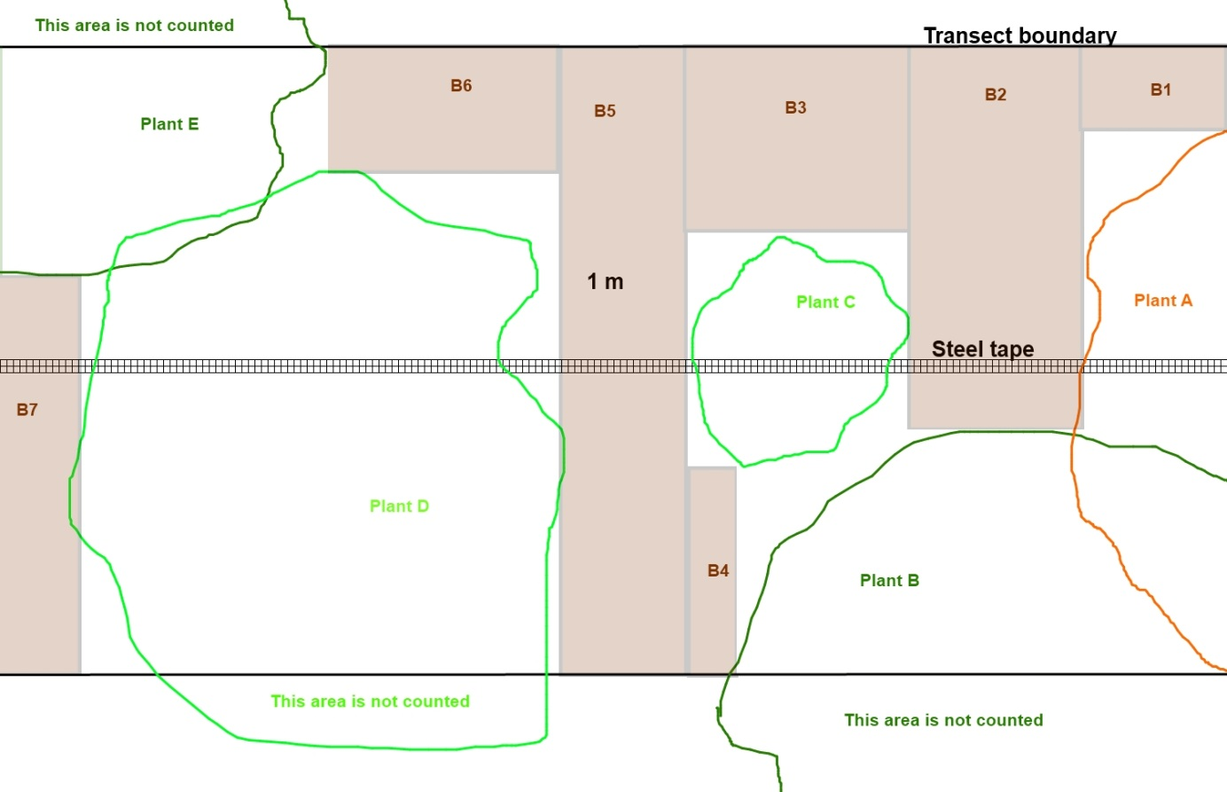

Figure : The area of ground with no canopy cover, indicated in brown.

Table : Calculation of the area of ground with no canopy in the example transect.

|  |  |  |  |  |  |  |
| --- | --- | --- | --- | --- | --- | --- |
| Bare ground |  | Start | End | Length (cm) | Width (cm) | Area (cm2) |
| B1 | No canopy | 0 | 23.01 | 23.01 | 13.99 | 322 |
| B2 | No canopy | 23.01 | 50.33 | 27.32 | 29.28 | 800 |
| B3 | No canopy | 50.33 | 85.62 | 35.29 | 29.54 | 1,043 |
| B4 | No canopy | 78.95 | 85.62 | 6.67 | 33.99 | 227 |
| B5 | No canopy | 85.62 | 109.54 | 23.92 | 100.00 | 2,392 |
| B6 | No canopy | 109.54 | 145.23 | 35.69 | 20.00 | 714 |
| B7 | No canopy | 181.96 | 196.60 | 14.64 | 62.22 | 911 |

Finally, the total cover for each species and for bare ground must be calculated by summing the totals for each species. As previously mentioned, the total area of the example transect is (197 cm x 100 cm =) 19,700 cm2, but the total canopy cover and ground with no canopy cover actually exceeds this amount (20,468 cm2) due to overlapping canopies. This is shown in Table 3 below.

Table : Total cover for each plant species and for the ground with no canopy cover.

|  |  |
| --- | --- |
| Species | Area (cm2) |
| 1 | 1,979 |
| 2 | 4,996 |
| 3 | 7,085 |
| No canopy | 6,408 |
| Total | 20,468 |

# Annex 3: Data sheets for baseline monitoring operations

***GPS coordinates***

|  |  |  |  |
| --- | --- | --- | --- |
| Fixed point photo |  | Centre point |  |
| SW corner |  | W transect marker |  |
| NW corner |  | N transect marker |  |
| NE corner |  | E transect marker |  |
| SE corner |  | S transect marker |  |

***Soil carbon***

|  |  |  |  |  |  |  |  |  |  |  |  |
| --- | --- | --- | --- | --- | --- | --- | --- | --- | --- | --- | --- |
| Hole | Horizon | Length of sides of hole (mm) | | | | Diagonals (mm) | | Volumes (cm3) | | | C conc (from Bemlab) (g/kg) |
| 1 | 2 | 3 | 4 | d1 | d2 | A: Original sandbag | B: Sandbag remainder | Hole (B-A) |
| H1 | 0-15 |  |  |  |  |  |  |  |  |  |  |
| 15-30 |  |  |  |  |  |  |  |  |  |  |
| H2 | 0-15 |  |  |  |  |  |  |  |  |  |  |
| 15-30 |  |  |  |  |  |  |  |  |  |  |
| H3 | 0-15 |  |  |  |  |  |  |  |  |  |  |
| 15-30 |  |  |  |  |  |  |  |  |  |  |
| H4 | 0-15 |  |  |  |  |  |  |  |  |  |  |
| 15-30 |  |  |  |  |  |  |  |  |  |  |
| H5 | 0-15 |  |  |  |  |  |  |  |  |  |  |
| 15-30 |  |  |  |  |  |  |  |  |  |  |
| H7 |  | Original hole number | | |  |  |  |  |  |  |  |

***Bulk density***

|  |  |  |  |  |  |  |  |  |  |  |  |  |  |  |
| --- | --- | --- | --- | --- | --- | --- | --- | --- | --- | --- | --- | --- | --- | --- |
| Hole | Length of sides of hole (mm) | | | | Diagonals (mm) | | Volumes (cm3) | | | | | Masses (g) | | |
| 1 | 2 | 3 | 4 | d1 | d2 | A: Sandbag initial | B: Sandbag remainder | Hole (B-A) | Gravel | Roots | Soil | Roots | Rocks |
| H6 |  |  |  |  |  |  |  |  |  |  |  |  |  |  |

***Litter sample weighing***

|  |  |  |  |  |  |
| --- | --- | --- | --- | --- | --- |
| A:Mass of oven tray (g) | B: Wet mass of litter and oven tray (g) | C: Dry mass of litter and oven tray) (g) | D: Wet mass of litter (B-A) (g) | E: Dry mass of litter (C-A) (g) | F: Weight fraction of moisture(D-E)/D |
|  |  |  |  |  |  |

|  |  |  |  |  |  |  |  |  |  |  |  |  |  |  |  |  |
| --- | --- | --- | --- | --- | --- | --- | --- | --- | --- | --- | --- | --- | --- | --- | --- | --- |
| ***Standing dead wood*** | | | | | | | | | | | | | | | | |
| Stem basal diameter (mm) | | Decomposition class * | | | Stem basal diameter (mm) | | | Decomposition class * | | | Stem basal diameter (mm) | | | Decomposition class * | | |
|  | |  | | |  | | |  | | |  | | |  | | |
|  | |  | | |  | | |  | | |  | | |  | | |
|  | |  | | |  | | |  | | |  | | |  | | |
|  | |  | | |  | | |  | | |  | | |  | | |
|  | |  | | |  | | |  | | |  | | |  | | |
|  | |  | | |  | | |  | | |  | | |  | | |
|  | |  | | |  | | |  | | |  | | |  | | |
|  | |  | | |  | | |  | | |  | | |  | | |
|  | |  | | |  | | |  | | |  | | |  | | |
|  | |  | | |  | | |  | | |  | | |  | | |
|  | |  | | |  | | |  | | |  | | |  | | |
|  | |  | | |  | | |  | | |  | | |  | | |
|  | |  | | |  | | |  | | |  | | |  | | |
|  |  | |  |  | |  |  | |  | | |  |  | | |
| ***Lying deadwood*** | | | | | | | | | | | | | | | | |
| Diameter (mm) [>5] | | Density state** | | Diameter (mm) [>5] | | | | Density state** | | Diameter (mm) [>5] | | | | | Density state** | |
|  | |  | |  | | | |  | |  | | | | |  | |
|  | |  | |  | | | |  | |  | | | | |  | |
|  | |  | |  | | | |  | |  | | | | |  | |
|  | |  | |  | | | |  | |  | | | | |  | |
|  | |  | |  | | | |  | |  | | | | |  | |
|  | |  | |  | | | |  | |  | | | | |  | |
|  | |  | |  | | | |  | |  | | | | |  | |
|  | |  | |  | | | |  | |  | | | | |  | |
|  | |  | |  | | | |  | |  | | | | |  | |
|  | |  | |  | | | |  | |  | | | | |  | |
|  | |  | |  | | | |  | |  | | | | |  | |
|  | |  | |  | | | |  | |  | | | | |  | |
|  | |  | |  | | | |  | |  | | | | |  | |
|  | |  | |  | | | |  | |  | | | | |  | |
|  | |  | |  | | | |  | |  | | | | |  | |
|  | |  | |  | | | |  | |  | | | | |  | |
|  | |  | |  | | | |  | |  | | | | |  | |
|  | |  | |  | | | |  | |  | | | | |  | |
|  | |  | |  | | | |  | |  | | | | |  | |
|  | |  | |  | | | |  | |  | | | | |  | |
|  | |  | |  | | | |  | |  | | | | |  | |
|  | |  | |  | | | |  | |  | | | | |  | |
|  | |  | |  | | | |  | |  | | | | |  | |
|  | |  | |  | | | |  | |  | | | | |  | |
| * Standing dead wood is divided into the following decomposition classes: A: tree with branches and twigs that resembles a live tree (except for leaves); B: tree with no twigs, but with persistent small and large branches; C: tree with large branches only; and D: bole only, no branches. | | | | | | | | | | ** Density is assigned to one of the following classes: 1: sound; 2: intermediate; or 3: rotten. | | | | | | |

|  |  |  |  |  |  |  |  |
| --- | --- | --- | --- | --- | --- | --- | --- |
| **Plant number** | **Stem diameter (mm)** | **Plant number** | **Stem diameter (mm)** | **Plant number** | **Stem diameter (mm)** | **Plant number** | **Stem diameter (mm)** |
|  |  |  |  |  |  |  |  |
|  |  |  |  |  |  |  |  |
|  |  |  |  |  |  |  |  |
|  |  |  |  |  |  |  |  |
|  |  |  |  |  |  |  |  |
|  |  |  |  |  |  |  |  |
|  |  |  |  |  |  |  |  |
|  |  |  |  |  |  |  |  |
|  |  |  |  |  |  |  |  |
|  |  |  |  |  |  |  |  |
|  |  |  |  |  |  |  |  |
|  |  |  |  |  |  |  |  |
|  |  |  |  |  |  |  |  |
|  |  |  |  |  |  |  |  |
|  |  |  |  |  |  |  |  |
|  |  |  |  |  |  |  |  |
|  |  |  |  |  |  |  |  |
|  |  |  |  |  |  |  |  |
|  |  |  |  |  |  |  |  |
|  |  |  |  |  |  |  |  |
|  |  |  |  |  |  |  |  |
|  |  |  |  |  |  |  |  |
|  |  |  |  |  |  |  |  |
|  |  |  |  |  |  |  |  |
|  |  |  |  |  |  |  |  |
|  |  |  |  |  |  |  |  |
|  |  |  |  |  |  |  |  |
|  |  |  |  |  |  |  |  |
|  |  |  |  |  |  |  |  |
|  |  |  |  |  |  |  |  |
|  |  |  |  |  |  |  |  |
|  |  |  |  |  |  |  |  |
|  |  |  |  |  |  |  |  |
|  |  |  |  |  |  |  |  |
|  |  |  |  |  |  |  |  |
|  |  |  |  |  |  |  |  |
|  |  |  |  |  |  |  |  |
|  |  |  |  |  |  |  |  |
|  |  |  |  |  |  |  |  |
|  |  |  |  |  |  |  |  |
|  |  |  |  |  |  |  |  |
|  |  |  |  |  |  |  |  |
|  |  |  |  |  |  |  |  |
|  |  |  |  |  |  |  |  |
|  |  |  |  |  |  |  |  |

|  |  |  |  |  |  |  |  |
| --- | --- | --- | --- | --- | --- | --- | --- |
| **Plant number** | **Stem height (mm)** | **Plant number** | **Stem height (mm)** | **Plant number** | **Stem height (mm)** | **Plant number** | **Stem height (mm)** |
|  |  |  |  |  |  |  |  |
|  |  |  |  |  |  |  |  |
|  |  |  |  |  |  |  |  |
|  |  |  |  |  |  |  |  |
|  |  |  |  |  |  |  |  |
|  |  |  |  |  |  |  |  |
|  |  |  |  |  |  |  |  |
|  |  |  |  |  |  |  |  |
|  |  |  |  |  |  |  |  |
|  |  |  |  |  |  |  |  |
|  |  |  |  |  |  |  |  |
|  |  |  |  |  |  |  |  |
|  |  |  |  |  |  |  |  |
|  |  |  |  |  |  |  |  |
|  |  |  |  |  |  |  |  |
|  |  |  |  |  |  |  |  |
|  |  |  |  |  |  |  |  |
|  |  |  |  |  |  |  |  |
|  |  |  |  |  |  |  |  |
|  |  |  |  |  |  |  |  |
|  |  |  |  |  |  |  |  |
|  |  |  |  |  |  |  |  |
|  |  |  |  |  |  |  |  |
|  |  |  |  |  |  |  |  |
|  |  |  |  |  |  |  |  |
|  |  |  |  |  |  |  |  |
|  |  |  |  |  |  |  |  |
|  |  |  |  |  |  |  |  |
|  |  |  |  |  |  |  |  |
|  |  |  |  |  |  |  |  |
|  |  |  |  |  |  |  |  |
|  |  |  |  |  |  |  |  |
|  |  |  |  |  |  |  |  |
|  |  |  |  |  |  |  |  |
|  |  |  |  |  |  |  |  |
|  |  |  |  |  |  |  |  |
|  |  |  |  |  |  |  |  |
|  |  |  |  |  |  |  |  |
|  |  |  |  |  |  |  |  |
|  |  |  |  |  |  |  |  |
|  |  |  |  |  |  |  |  |
|  |  |  |  |  |  |  |  |
|  |  |  |  |  |  |  |  |
|  |  |  |  |  |  |  |  |
|  |  |  |  |  |  |  |  |

|  |  |  |  |  |  |
| --- | --- | --- | --- | --- | --- |
| ***Belt transects (two 50m intersections)*** | |  |  |  |  |
| Species | Width (cm) | Length (cm) | Species | Width (cm) | Length (cm) |
|  |  |  |  |  |  |
|  |  |  |  |  |  |
|  |  |  |  |  |  |
|  |  |  |  |  |  |
|  |  |  |  |  |  |
|  |  |  |  |  |  |
|  |  |  |  |  |  |
|  |  |  |  |  |  |
|  |  |  |  |  |  |
|  |  |  |  |  |  |
|  |  |  |  |  |  |
|  |  |  |  |  |  |
|  |  |  |  |  |  |
|  |  |  |  |  |  |
|  |  |  |  |  |  |
|  |  |  |  |  |  |
|  |  |  |  |  |  |
|  |  |  |  |  |  |
|  |  |  |  |  |  |
|  |  |  |  |  |  |
|  |  |  |  |  |  |
|  |  |  |  |  |  |
|  |  |  |  |  |  |
|  |  |  |  |  |  |
|  |  |  |  |  |  |
|  |  |  |  |  |  |
|  |  |  |  |  |  |
|  |  |  |  |  |  |
|  |  |  |  |  |  |
|  |  |  |  |  |  |
|  |  |  |  |  |  |
|  |  |  |  |  |  |
|  |  |  |  |  |  |
|  |  |  |  |  |  |
|  |  |  |  |  |  |
|  |  |  |  |  |  |
|  |  |  |  |  |  |
|  |  |  |  |  |  |
|  |  |  |  |  |  |
|  |  |  |  |  |  |
|  |  |  |  |  |  |
|  |  |  |  |  |  |
|  |  |  |  |  |  |
|  |  |  |  |  |  |

|  |  |  |  |  |  |
| --- | --- | --- | --- | --- | --- |
| ***Quadrats (four 2 m x 2 m quadrats centred in the four quarters of the plot)*** | | | | | |
| Species | Q # | %cover | Species | Q # | %cover |
|  |  |  |  |  |  |
|  |  |  |  |  |  |
|  |  |  |  |  |  |
|  |  |  |  |  |  |
|  |  |  |  |  |  |
|  |  |  |  |  |  |
|  |  |  |  |  |  |
|  |  |  |  |  |  |
|  |  |  |  |  |  |
|  |  |  |  |  |  |
|  |  |  |  |  |  |
|  |  |  |  |  |  |
|  |  |  |  |  |  |
|  |  |  |  |  |  |
|  |  |  |  |  |  |
|  |  |  |  |  |  |
|  |  |  |  |  |  |
|  |  |  |  |  |  |
|  |  |  |  |  |  |
|  |  |  |  |  |  |
|  |  |  |  |  |  |
|  |  |  |  |  |  |
|  |  |  |  |  |  |
|  |  |  |  |  |  |
|  |  |  |  |  |  |
|  |  |  |  |  |  |
|  |  |  |  |  |  |
|  |  |  |  |  |  |
|  |  |  |  |  |  |
|  |  |  |  |  |  |
|  |  |  |  |  |  |
|  |  |  |  |  |  |
|  |  |  |  |  |  |
|  |  |  |  |  |  |
|  |  |  |  |  |  |
|  |  |  |  |  |  |
|  |  |  |  |  |  |
|  |  |  |  |  |  |
|  |  |  |  |  |  |
|  |  |  |  |  |  |
|  |  |  |  |  |  |
|  |  |  |  |  |  |
|  |  |  |  |  |  |

|  |  |  |  |  |  |  |  |  |  |  |  |  |  |
| --- | --- | --- | --- | --- | --- | --- | --- | --- | --- | --- | --- | --- | --- |
| Sample number | Mass | Date | Mass | Date | Mass | Date | Mass | Date | Mass | Date | Mass | Date | Final Mass |
|  |  |  |  |  |  |  |  |  |  |  |  |  |  |
|  |  |  |  |  |  |  |  |  |  |  |  |  |  |
|  |  |  |  |  |  |  |  |  |  |  |  |  |  |
|  |  |  |  |  |  |  |  |  |  |  |  |  |  |
|  |  |  |  |  |  |  |  |  |  |  |  |  |  |
|  |  |  |  |  |  |  |  |  |  |  |  |  |  |
|  |  |  |  |  |  |  |  |  |  |  |  |  |  |
|  |  |  |  |  |  |  |  |  |  |  |  |  |  |
|  |  |  |  |  |  |  |  |  |  |  |  |  |  |
|  |  |  |  |  |  |  |  |  |  |  |  |  |  |
|  |  |  |  |  |  |  |  |  |  |  |  |  |  |
|  |  |  |  |  |  |  |  |  |  |  |  |  |  |
|  |  |  |  |  |  |  |  |  |  |  |  |  |  |
|  |  |  |  |  |  |  |  |  |  |  |  |  |  |
|  |  |  |  |  |  |  |  |  |  |  |  |  |  |
|  |  |  |  |  |  |  |  |  |  |  |  |  |  |
|  |  |  |  |  |  |  |  |  |  |  |  |  |  |
|  |  |  |  |  |  |  |  |  |  |  |  |  |  |
|  |  |  |  |  |  |  |  |  |  |  |  |  |  |
|  |  |  |  |  |  |  |  |  |  |  |  |  |  |
|  |  |  |  |  |  |  |  |  |  |  |  |  |  |
|  |  |  |  |  |  |  |  |  |  |  |  |  |  |
|  |  |  |  |  |  |  |  |  |  |  |  |  |  |
|  |  |  |  |  |  |  |  |  |  |  |  |  |  |
|  |  |  |  |  |  |  |  |  |  |  |  |  |  |
|  |  |  |  |  |  |  |  |  |  |  |  |  |  |
|  |  |  |  |  |  |  |  |  |  |  |  |  |  |
|  |  |  |  |  |  |  |  |  |  |  |  |  |  |

1. The methodology for this project is the CDM methodology AR-AM0002 v3: . It can be downloaded from <http://cdm.unfccc.int/UserManagement/FileStorage/L1ZYHU4X5QRPFS2IVGDM8T90N3W6CJ>. However, there are a number of deviations from these equations, and consequently the Project Document should be used as a reference. The PD can be downloaded from: <http://dl.dropbox.com/u/8458610/Thicket%20project/Validation%20docs/VCS_ABFRP_PD_C4ES_05Sep2011_V3.2.pdf>
2. Available from: <http://www.spatialecology.com/htools/rndpnts.php>.
3. http://www.bemlab.co.za/uploads/SRF06ABR3-Spesiaal.pdf